**Massage Therapy: What You Should Know**

By [Kathi Valeii](https://www.verywellhealth.com/kathi-valeii-5085183)

Updated on July 10, 2024

 Medically reviewed by [Laura Campedelli, DPT](https://www.verywellhealth.com/laura-campedelli-pt-dpt-4776034)

Table of Contents

Table of Contents

* [Health Benefits](https://www.verywellhealth.com/massage-therapy-5212944#toc-health-benefits-of-massage-therapy)
* [Types of Massage](https://www.verywellhealth.com/massage-therapy-5212944#toc-types-of-massage)
* [Side Effects and Risks](https://www.verywellhealth.com/massage-therapy-5212944#toc-side-effects-and-risks)
* [Cost](https://www.verywellhealth.com/massage-therapy-5212944#toc-cost)
* [Frequently Asked Questions](https://www.verywellhealth.com/massage-therapy-5212944#toc-frequently-asked-questions-018a993a-5b1d-4129-9321-ae449f0b8571)

Cultures around the world have used massage since ancient times. It is one of the oldest techniques humans have used to treat pain. Today, massage therapy treats stress, [anxiety](https://www.verywellhealth.com/severe-anxiety-5200310), and certain health conditions.

There are many different types of massage therapy, each with its own unique approach and benefits. During massage therapy, a massage therapist will use their hands, fingers, elbows, forearms, or a massage device to manipulate your body’s [soft tissues](https://www.verywellhealth.com/what-is-connective-tissue-190043) (muscles, tendons, ligaments, and fascia).1 The process releases tension and may relieve some symptoms and heal muscle injuries.2

This article explains massage therapy benefits, types, side effects, and cost.

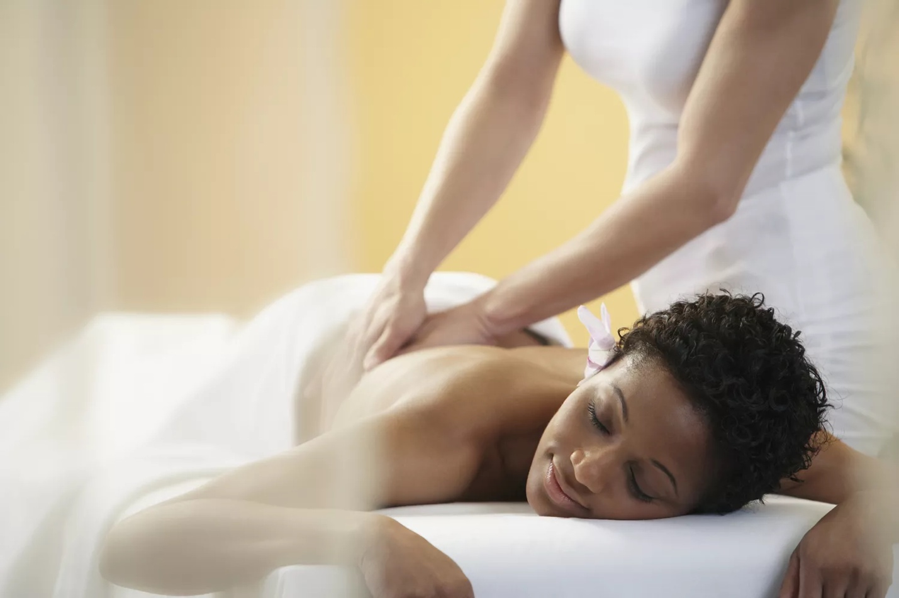

Jon Feingersh Photography Inc. / Getty Images

Health Benefits of Massage Therapy

People use massage therapy for pain, muscle injuries, and supportive therapy for some health conditions. The overall benefits of massage may include:32

* Relieves [muscle tension](https://www.verywellhealth.com/muscle-pain-what-you-should-know-190093)
* Promotes better [circulation](https://www.verywellhealth.com/cardiovascular-system-8695175)
* Supports [immunity](https://www.verywellhealth.com/ways-to-boost-your-immune-system-naturally-89283)
* Reduces stress and anxiety 4
* Increases relaxation
* Faster healing from [soft tissue injuries](https://www.verywellhealth.com/first-aid-4014723)
* Reduces pregnancy pain and swelling
* Relieves [fibromyalgia](https://www.verywellhealth.com/fibromyalgia-symptoms-716139) symptoms 5
* Reduces [cancer pain](https://www.verywellhealth.com/does-cancer-hurt-2249010)
* Relieves [constipation](https://www.verywellhealth.com/when-is-constipation-an-emergency-7852525) 6
* Improves sleep

Research supports massage therapy for back, neck, and shoulder pain. However, most studies show that it is most useful for acute pain and less effective at treating chronic pain.1

[Benefits and Techniques of Oncology Massage](https://www.verywellhealth.com/massage-for-cancer-2249314)

Types of Massage

Depending on your situation, you may benefit from one of a variety of types of massage therapy. Some styles focus on overall relaxation and relieving muscle tension, while others focus more specifically on injured soft tissues. Often, massage therapists utilize multiple techniques as needed.

Swedish Massage

Swedish massage, also called “classic massage,” is the most well-known massage technique in the world. It utilizes a variety of massage styles, including:7

* Long, gliding strokes
* Kneading muscles
* Lifting muscles
* Tapping
* Friction
* Vibration or shaking

Massage strokes move from the extremities inward, toward the heart. The main benefits of this massage style include:8

* Relaxation
* [Scar tissue healing](https://www.verywellhealth.com/scar-tissue-massage-and-management-2696639)
* Improved circulation

Studies have confirmed some benefits of Swedish massage. For example, in a 2017 quasi-experimental study, 48 intensive care unit (ICU) patients received a 30-minute Swedish massage. Immediately after and 30 minutes after, they showed reduced anxiety and improved [vital signs](https://www.verywellhealth.com/normal-adult-vital-signs-914750).9

In addition, in a 2013 experimental randomized controlled trial, 16 participants with [high blood pressure](https://www.verywellhealth.com/hypertensive-heart-disease-5095180) were evaluated to see if Swedish massage could reduce blood pressure. Half of the participants received an hour of Swedish massage a week for four weeks, while the control group received rest at the same intervals.

After the trial, rest and massage reduced blood pressure and heart rate. However, Swedish massage had a more significant and sustained effect.10

[Craniosacral Therapy: More Than a Head Massage](https://www.verywellhealth.com/craniosacral-therapy-8415537)

Deep Tissue Massage

As the name suggests, deep tissue massage focuses on deeper muscles and soft tissue. While it uses a lot of the same style of strokes and movement as Swedish massage, it feels less relaxing and can sometimes be uncomfortable or painful. The purpose of this type of massage is to offer pain relief from [knots](https://www.verywellhealth.com/trigger-point-2696165) or other soft-tissue-related pain and injury.

Some research supports deep tissue massage for pain relief, especially in the short term. For example, in a 2019 randomized controlled trial, researchers put 619 adults with neck pain into one of four groups: deep tissue massage, exercise, exercise and massage, or advice to stay active.

After one year, there were no significant clinical changes in pain. However, pain intensity in the massage and combination groups was improved in the shorter term (seven and 12 weeks) compared with the advice group.11

[Massage, Rolfing, and Other Bodywork for Fibromyalgia](https://www.verywellhealth.com/massage-rolfing-other-bodywork-715645)

0 seconds of 1 minute, 35 secondsVolume 90%

1:35

**Click Play to Learn More About Deep Tissue Massages**

This video has been medically reviewed by [Casey Gallagher, MD](https://www.verywellhealth.com/casey-gallagher-md-4685028).

Sports Massage

Athletes often receive [sports massage](https://www.verywellhealth.com/sports-massage-what-are-the-benefits-1337670) to help with performance or rehabilitation from a sports-related injury. This type of massage focuses on the particular muscle groups relevant to the athlete’s sport.

Some research supports the use of sports massage in athletes. For instance, a 2020 systematic review and meta-analysis included 29 randomized studies that measured the effect of massage on sporting performance and recovery. While researchers found no evidence that sports massage directly improved performance, it did improve flexibility and delayed onset of muscle soreness.12

[Massage Therapy: What You Should Know](https://www.verywellhealth.com/massage-therapy-5212944)

Hot Stone Massage

A hot stone massage utilizes unique stones that are heated and placed on your body. In addition, a massage therapist may hold the stones while they use a variety of massage styles. This style of massage typically promotes relaxation.

Some research has found benefits of hot stone for this purpose. For example, in a 2019 randomized controlled trial, 60 people on maintenance [hemodialysis](https://www.verywellhealth.com/dialysis-8654458) ([kidney disease](https://www.verywellhealth.com/facts-about-chronic-kidney-disease-6260459) treatment in which blood filters through a machine) were assigned to a hot stone massage or control group.

The massage group received massages three times a week for four weeks. At the end of the study, participants who received massage showed significant improvements in their sleep quality compared with the control group.13

Aromatherapy Massage

Aromatherapy massage incorporates scent by using [essential oils](https://www.verywellhealth.com/essential-oils-for-arthritis-5087715). The massage therapist alternates between gentle and firm pressure while using essential oils that have been diluted with a carrier oil to move quickly across the skin.

This type of massage promotes relaxation and pain relief. Some research supports this type of massage for these purposes. For example, in a 2017 randomized controlled clinical study, 46 people with [neuropathic pain](https://www.verywellhealth.com/peripheral-neuropathy-3145943) (a nerve dysfunction) were placed in a massage or control group.

The massage group received aromatherapy massage three times a week for four weeks, while the control group received routine care. The massage group’s pain scores significantly decreased compared with the control group, and their quality of life improved.14

If you have fragrance sensitivity or a known allergy to scents, you should avoid an aromatherapy massage.

Pregnancy Massage

A [pregnancy massage](https://www.verywellhealth.com/pregnancy-massage-benefits-contraindications-and-safety-5190485), also called a prenatal massage, can help people with the discomforts of pregnancy. Benefits of pregnancy massage include:15

* Reducing back and leg pain
* Reducing stress and anxiety
* Improving mood
* Improving sleep

The massage style your therapist uses will probably be one or more of the Swedish massage styles, although they may incorporate others that suit your situation.

The American College of Obstetricians and Gynecologists (ACOG) considers pregnancy massage a safe choice that promotes relaxation and circulation.16 However, it is always best to check with a healthcare provider to evaluate your specific situation before scheduling one to be sure it is safe in your circumstance.

Unless the table has a cutout for your tummy, ACOG recommends lying on your side rather than your stomach. Seek out a massage therapist trained to work on pregnant bodies, and be sure to inform them that you are pregnant.16

Reflexology

Reflexology stimulates the reflex maps on the hands, feet, and ears. A reflexologist uses their fingers and thumbs to put pressure on an area away from the reflex point to energize other body parts.

The [benefits of reflexology](https://www.verywellhealth.com/foot-reflexology-7111712) include:17

* Reduces stress
* Reduces pain
* Reduces the need for pain medication
* Stimulates endorphins
* Speeds recovery

While there is little research supporting it, people have experienced positive benefits from the therapy anecdotally. Since there is little risk, it is widely accepted.

**Recap**

Different types of massages treat different things, and some are backed by more research than others. Swedish (or classic) massage is the most common.

[Scalp Massage: Weighing the Benefits and Drawbacks](https://www.verywellhealth.com/scalp-massage-8623993)

Side Effects and Risks

Usually, massage therapy is safe. However, rarely, there may be some risks associated with it, including:1

* [Blood clots](https://www.verywellhealth.com/overview-blood-clots-1745326)
* [Nerve injuries](https://www.verywellhealth.com/what-are-pinched-nerves-189255)
* [Bone fracture](https://www.verywellhealth.com/do-i-have-a-broken-bone-4143129)

Due to the vigorous nature of the therapy, deep tissue massage may pose a greater risk. In addition, older people, who generally have higher health risks, may be more susceptible.

Cost

The cost of massage therapy varies depending on the massage therapist you choose and your geographic location. However, the national average price is $60 for a one-hour session.18

Sometimes, but not always, massage therapy is covered by insurance. Usually, you will need a healthcare provider's or doctor’s [referral](https://www.verywellhealth.com/what-is-a-referral-health-insurance-1738605) to receive insurance benefits. In addition, if you were injured on the job, workers’ compensation may pay for your massage.18 Check with your insurance or benefits plan to be sure.

Since costs can vary widely, check around and compare the prices and staff training. Referrals from people you know can also help you find someone who is reputable and affordable.

Summary

People use massage therapy for relaxation, pain management, and recovery from injuries. There are many types of massage therapy, including Swedish massage, deep tissue massage, sports massage, prenatal massage, reflexology, and aromatherapy massage. Each has unique benefits, and research supports some types more than others. There is little risk associated with massage, but if you are at high risk of bone, nerve, or circulatory problems, you may want to check with a healthcare provider first.

A Word From Verywell

If you feel stressed or have a tight muscle, massage may be an excellent option to consider. Ask friends, coworkers, and family members for referrals to reputable massage therapists in your area, and be sure to tell your massage therapists about any health risks you have. In addition, let them know what makes you comfortable. For example, let them know what kind of pressure you prefer, and speak up if anything hurts.